### Entity Relationship Diagram

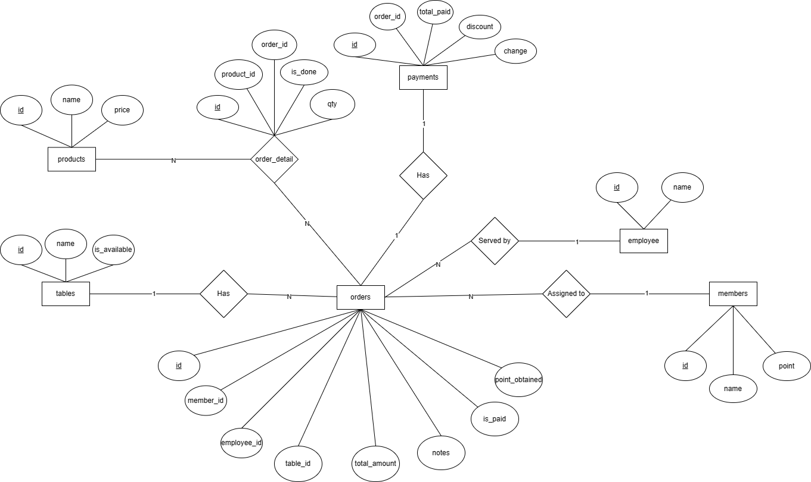

### Todolist

<https://docs.google.com/spreadsheets/d/1OVVETo103GAa_nj7WUYFK-gbiTpGdMYEnrvusuY1U_c/edit?usp=sharing>